Traffic 3.1 – Getting Started

Matthias Loeu

Version 0.6
Date: 10 November 2006
Table of Contents
Part 1 – Installation 3
Installing EiffelStudio 3
Installing EiffelMedia 3
Installing bundled application 3
Part 2 – Creating an application from scratch 5
Starting over... with the new version 11
References 12

Version 3.0 is the latest release of Traffic [1] at the time of writing. It forms the basis of this guide. I will update the guide to Traffic 3.1 once it is released.
The operating system I am using is “Windows XP (32 bit)”. The exact procedure for other operating systems may differ.

Part 1 – Installation
This section is based on the existing Installation guide [2].
First you will have to install EiffelStudio and EiffelMedia:

Installing EiffelStudio
- Although not required, I recommend you to install the “Microsoft .NET Framework” if you don't have it already. [3]
- Download EiffelStudio 5.6 from [4]. Filename is “Eiffel56_1218_windows.msi”
- Run the executable file as a system administrator and follow the instructions on screen.

Installing EiffelMedia
- Downlad EiffelMedia 0.8.0 from [5]. (Note: Today (17 August 2006) the webpage does not work. There seems to be a new version (0.9.0), but it can not be downloaded – and neither any older versions!)
- Run the installer as a system administrator and follow the on screen instructions.
- Logoff/logon or restart your computer. Otherwise it will not work.
From now on you don't need administrator privileges any more.
If you're done, download the Traffic zip-file [1] and unzip it to your project folder or any other place you have write and executable permission. The included applications such as Flat Hunt are located in the respective directory under traffic/example. For every application you wish to run, you will have to do following:

Installing bundled application
- Open a command shell. On the keyboard, you may press “Windows-button” and “R”, type “cmd”, then Enter.
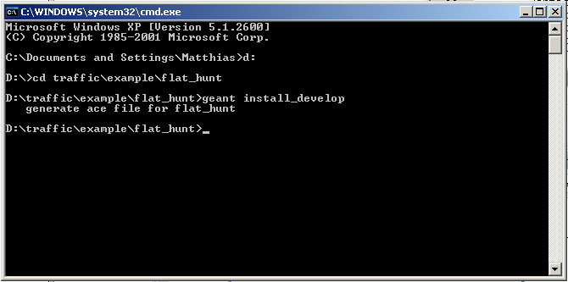
- Go to the directory of the application you want to run, for example “D:\traffic\example\flat_hunt”.
- Type “geant install_develop” and press enter. This command will generate a file for you that is known as the ace-file. It is called developer.ace and you can find it in the folder where the application you want to compile is located. The generated ace-file contains all the needed data for compiling and running the application on your specific system.
- Start EiffelStudio.
- In the start dialog choose "Open existing Ace (control file)" and click on "Next". If the dialog does not appear, click on "File ->New Project...".
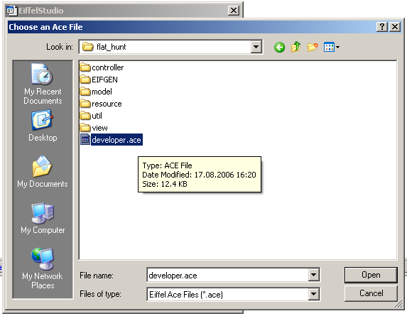
- This will open a file dialog that lets you choose the Ace file. Browse to the directory where the application is located (e.g. D:\traffic\example\flat_hunt), choose “developer.ace” and click on “Open”.
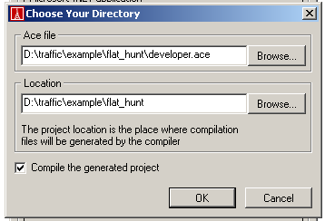
- The next dialog lets you choose the project directory. In most cases you can leave both paths (Ace file and location) as EiffelStudio proposes. Make sure that the checkbox for compiling the generated project is selected. Click on "OK". This will start the compilation of the project. Depending on your computer you may wait a while...
- Once the project is compiled you can execute (debug) it by clicking on the "Debug" button in EiffelStudio or by hitting F5.

Part 2 – Creating an application from scratch
The easiest way to create a new application is not to actually create one. You can copy an existing application and modify it until you get what you want.
Otherwise:
- Start EiffelStudio
- In the start dialog choose “Create a new project” and select “Basic application”. Click “Next”.
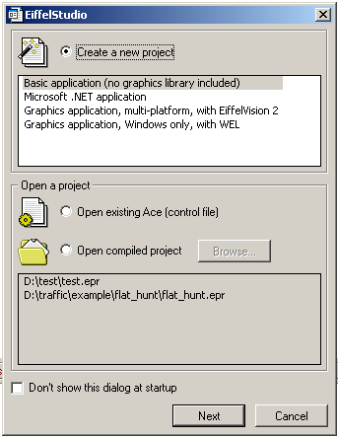
- Follow the instructions on the next screen.
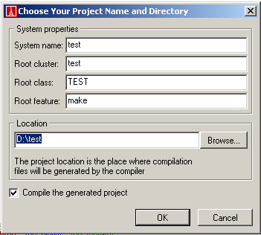
- Now go to the folder where you saved your project.
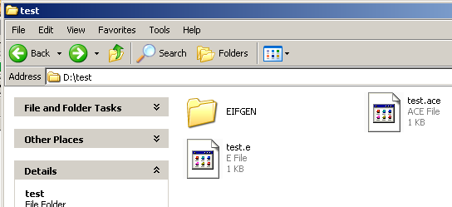
- Open The ace-File with a text editor. You need to add the Traffic, Eiffel Media, Gobo and some other Libraries to your project. Add following lines to under “cluster” for the Eiffel Media Library:
  - em: "${EM}/library"
  - highscore (em): "$/highscore"
  - settings (em): "$/settings"
  - audio (em): "$/audio"
  - cdrom (em): "$/cdrom"
  - event (em): "$/event"
  - timer (em): "$/timer"
  - utility (em): "$/utility"
  - goof (em): "$/goof"
  - "object" (goof): "$/object"
  - xy ("object"): "$/xy"
  - xz ("object"): "$/xz"
  - force (goof): "$/force"
  - collision (goof): "$/collision"
  - loader (goof): "$/loader"
  - joystick (em): "$/joystick"
  - network (em): "$/network"
  - classic (network): "$/classic"
  - multiplayer (network): "$/multiplayer"
  - net_system_objects (multiplayer): "$/net_system_objects"
  - net_system_events (multiplayer): "$/net_system_events"
  - video (em): "$/video"
  - video_decoder (video): "$/video_decoder"
  - ev_widget (video): "$/ev_widget"
  - implementation (ev_widget): "$/implementation"
  - mswin (implementation): "$/mswin"
  - implementation_interface (implementation): "$/implementation_interface"
  - interface (ev_widget): "$/interface"
  - animation (video): "$/animation"
  - collision_detection (video): "$/collision_detection"
  - font (video): "$/font"
  - figure (video): "$/figure"
  - container (video): "$/container"
  - opengl (video): "$/opengl"
  - widget (em): "$/widget"
  - background (widget): "$/background"
  - border (widget): "$/border"
  - input (widget): "$/input"
  - widgets (widget): "$/widgets"
  - delegates (widget): "$/delegates"
  - basic_delegates (delegates): "$/basic_delegates"
  - eclipse_delegates (delegates): "$/eclipse_delegates"
  - generated_wrapper (em): "$/generated_wrapper"
  - eiffel (generated_wrapper): "$/eiffel"
  - sdl_external_external (eiffel): "$/external"
  - sdl_external_struct (sdl_external_external): "$/struct"
  - sdl_external_struct_spec (sdl_external_struct): "$/spec"
  - sdl_external_struct_ise (sdl_external_struct_spec): "$/ise"
  - sdl_external_enum (sdl_external_external): "$/enum"
  - sdl_external_enum_spec (sdl_external_enum): "$/spec"
  - sdl_external_enum_ise (sdl_external_enum_spec): "$/ise"
  - sdl_external_union (sdl_external_external): "$/union"
  - sdl_external_union_spec (sdl_external_union): "$/spec"
  - sdl_external_union_ise (sdl_external_union_spec): "$/ise"
  - sdl_external_function (sdl_external_external): "$/function"
  - sdl_external_function_spec (sdl_external_function): "$/spec"
  - sdl_external_function_ise (sdl_external_function_spec): "$/ise"
  - sdl_abstraction_abstraction (eiffel): "$/abstraction"
  - sdl_abstraction_struct (sdl_abstraction_abstraction): "$/struct"
  - sdl_abstraction_function (sdl_abstraction_abstraction): "$/function"
  - sdl_abstraction_callback (sdl_abstraction_abstraction): "$/callback"
  - sdl_abstraction_union (sdl_abstraction_abstraction): "$/union"
- Then add following lines for the Gobo Library:
  - gobo: "${GOBO}"
  - kl_kernel (gobo): "${GOBO}/library/kernel"
  - kl_basic (kl_kernel): "$/basic"
  - kl_elks (kl_kernel): "$/elks"
  - kl_io (kl_kernel): "$/io"
  - kl_misc (kl_kernel): "$/misc"
  - kl_unicode (kl_kernel): "$/unicode"
  - kl_support (kl_kernel): "$/support"
  - kl_spec (kl_kernel): "$/spec"
  - kl_spec_ise (kl_spec): "$/ise"
  - lx_lexical (gobo): "${GOBO}/library/lexical"
  - lx_automaton (lx_lexical): "$/automaton"
  - lx_error (lx_lexical): "$/error"
  - lx_generation (lx_lexical): "$/generation"
  - lx_lex (lx_lexical): "$/lex"
  - lx_regexp (lx_lexical): "$/regexp"
  - lx_scanner (lx_lexical): "$/scanner"
  - lx_skeleton (lx_lexical): "$/skeleton"
  - lx_support (lx_lexical): "$/support"
  - ma_math (gobo): "${GOBO}/library/math"
  - ma_decimal (ma_math): "$/decimal"
  - pr_parse (gobo): "${GOBO}/library/parse"
  - pr_error (pr_parse): "$/error"
  - pr_fsm (pr_parse): "$/fsm"
  - pr_generation (pr_parse): "$/generation"
  - pr_grammar (pr_parse): "$/grammar"
  - pr_parser (pr_parse): "$/parser"
  - pr_skeleton (pr_parse): "$/skeleton"
  - pr_support (pr_parse): "$/support"
  - pr_yacc (pr_parse): "$/yacc"
  - dp_pattern (gobo): "${GOBO}/library/pattern"
  - dp_bridge (dp_pattern): "$/bridge"
  - dp_command (dp_pattern): "$/command"
  - rx_regexp (gobo): "${GOBO}/library/regexp"
  - rx_interface (rx_regexp): "$/interface"
  - rx_pcre (rx_regexp): "$/pcre"
  - rx_support (rx_regexp): "$/support"
  - st_string (gobo): "${GOBO}/library/string"
  - st_collation (st_string): "$/collation"
  - st_unicode (st_string): "$/unicode"
  - st_support (st_string): "$/support"
  - st_formatter (st_string): "$/formatter"
  - st_general (st_formatter): "$/general"
  - st_parameter (st_formatter): "$/parameter"
  - ds_structure (gobo): "${GOBO}/library/structure"
  - ds_container (ds_structure): "$/container"
  - ds_dispenser (ds_structure): "$/dispenser"
  - ds_list (ds_structure): "$/list"
  - ds_set (ds_structure): "$/set"
  - ds_sort (ds_structure): "$/sort"
  - ds_support (ds_structure): "$/support"
  - ds_table (ds_structure): "$/table"
  - ts_test (gobo): "${GOBO}/library/test"
  - ts_generation (ts_test): "$/generation"
  - ts_harness (ts_test): "$/harness"
  - dt_time (gobo): "${GOBO}/library/time"
  - dt_clock (dt_time): "$/clock"
  - dt_date (dt_time): "$/date"
  - dt_format (dt_time): "$/format"
  - dt_time_zone (dt_time): "$/time_zone"
  - et_tools (gobo): "${GOBO}/library/tools"
  - et_eiffel_eiffel (et_tools): "$/eiffel"
  - et_eiffel_ast (et_eiffel_eiffel): "$/ast"
  - et_eiffel_assertion (et_eiffel_ast): "$/assertion"
  - et_eiffel_class (et_eiffel_ast): "$/class"
  - et_eiffel_cluster (et_eiffel_ast): "$/cluster"
  - et_eiffel_constant (et_eiffel_ast): "$/constant"
  - et_eiffel_expression (et_eiffel_ast): "$/expression"
  - et_eiffel_feature (et_eiffel_ast): "$/feature"
  - et_eiffel_instruction (et_eiffel_ast): "$/instruction"
  - et_eiffel_misc (et_eiffel_ast): "$/misc"
  - et_eiffel_name (et_eiffel_ast): "$/name"
  - et_eiffel_type (et_eiffel_ast): "$/type"
  - et_eiffel_compilation (et_eiffel_eiffel): "$/compilation"
  - et_eiffel_dynamic (et_eiffel_eiffel): "$/dynamic"
  - et_eiffel_error (et_eiffel_eiffel): "$/error"
  - et_eiffel_generation (et_eiffel_eiffel): "$/generation"
  - et_eiffel_parser (et_eiffel_eiffel): "$/parser"
  - et_eiffel_processor (et_eiffel_eiffel): "$/processor"
  - et_lace_lace (et_tools): "$/lace"
  - et_lace_ast (et_lace_lace): "$/ast"
  - et_lace_error (et_lace_lace): "$/error"
  - et_lace_parser (et_lace_lace): "$/parser"
  - et_xace_xace (et_tools): "$/xace"
  - et_xace_ast (et_xace_xace): "$/ast"
  - et_xace_error (et_xace_xace): "$/error"
  - et_xace_generator (et_xace_xace): "$/generator"
  - et_xace_parser (et_xace_xace): "$/parser"
  - et_xace_support (et_xace_xace): "$/support"
  - et_xace_universe (et_xace_xace): "$/universe"
  - ut_utility (gobo): "${GOBO}/library/utility"
  - ut_error (ut_utility): "$/error"
  - ut_formatter (ut_utility): "$/formatter"
  - ut_command (ut_utility): "$/command"
  - ut_support (ut_utility): "$/support"
  - ut_transcoder (ut_utility): "$/transcoder"
  - ut_uri (ut_utility): "$/uri"
  - xm_xml (gobo): "${GOBO}/library/xml"
  - xm_position (xm_xml): "$/position"
  - xm_source (xm_xml): "$/source"
  - xm_general (xm_xml): "$/general"
  - xm_event (xm_xml): "$/event"
  - xm_tree (xm_xml): "$/tree"
  - xm_formatter (xm_xml): "$/formatter"
  - xm_resolver (xm_xml): "$/resolver"
  - xm_resolver_interface (xm_resolver): "$/interface"
  - xm_catalog (xm_resolver): "$/catalog"
  - xm_simple (xm_resolver): "$/simple"
  - xm_uri (xm_resolver): "$/uri"
  - xm_parser (xm_xml): "$/parser"
  - xm_interface (xm_parser): "$/interface"
  - xm_eiffel (xm_parser): "$/eiffel"
  - xm_no_expat (xm_parser): "$/no_expat"
  - xm_xml_xpointer (xm_xml): "${GOBO}/library/xml/xpointer"
  - xm_xpointer_common (xm_xml_xpointer): "$/common"
  - xm_xpointer_event (xm_xml_xpointer): "$/event"
  - xm_xml_xslt (gobo): "${GOBO}/library/xml/xslt"
  - xm_pattern (xm_xml_xslt): "$/pattern"
  - xm_xslt_function (xm_xml_xslt): "$/function"
  - xm_instruction (xm_xml_xslt): "$/instruction"
  - xm_style (xm_xml_xslt): "$/style"
  - xm_tracing (xm_xml_xslt): "$/tracing"
  - xm_number (xm_xml_xslt): "$/number"
  - xm_xslt_sort (xm_xml_xslt): "$/sort"
  - xm_xslt_event (xm_xml_xslt): "$/event"
  - xm_runtime (xm_xml_xslt): "$/runtime"
  - xm_xslt_core (xm_xml_xslt): "$/core"
  - xm_xml_xpath (gobo): "${GOBO}/library/xml/xpath"
  - xm_data_model (xm_xml_xpath): "$/data_model"
  - xm_tinytree (xm_xml_xpath): "$/tinytree"
  - xm_xpath_tree (xm_xml_xpath): "$/tree"
  - xm_value (xm_xml_xpath): "$/value"
  - xm_expression (xm_xml_xpath): "$/expression"
  - xm_xpath_event (xm_xml_xpath): "$/event"
  - xm_function (xm_xml_xpath): "$/function"
  - xm_sort (xm_xml_xpath): "$/sort"
  - xm_stand_alone (xm_xml_xpath): "$/stand_alone"
  - xm_node_test (xm_xml_xpath): "$/node_test"
  - xm_type (xm_xml_xpath): "$/type"
  - xm_xpath_xpointer (xm_xml_xpath): "$/xpointer"
  - xm_core (xm_xml_xpath): "$/core"
- Likewise with the EWG Library:
  - ewg: "${EWG}"
  - ewg_runtime (ewg): "${EWG}/library/runtime/eiffel"
  - ewg_spec (ewg_runtime): "$/spec"
  - ewg_runtime_spec_ise (ewg_spec): "$/ise"
- The time library:
  - time (ise): "$/time"
  - format (time): "$/format"
  - english (format): "$/english"
- And finally the Traffic Library (please note you have to adjust the path to the library below!):
  - traffic: "../traffic/library"
  - default
  - assertion (all)
  - end
  - traffic_utility (traffic): "$/utility"
  - default
  - assertion (all)
  - end
  - traffic_base_extension (traffic_utility): "$/base_extension"
  - default
  - assertion (all)
  - end
  - traffic_dispenser (traffic_base_extension): "$/dispenser"
  - default
  - assertion (all)
  - end
  - graph_graph (traffic_base_extension): "$/graph"
  - default
  - assertion (all)
  - end
  - graph_implementation (graph_graph): "$/implementation"
  - default
  - assertion (all)
  - end
  - graph_adjacency_matrix_graph (graph_implementation): "$/adjacency_matrix_graph"
  - default
  - assertion (all)
  - end
  - graph_linked_graph (graph_implementation): "$/linked_graph"
  - default
  - assertion (all)
  - end
  - graph_structure (graph_graph): "$/structure"
  - default
  - assertion (all)
  - end
  - graph_walker (graph_graph): "$/walker"
  - default
  - assertion (all)
  - end
  - traffic_topological_sort (traffic_base_extension): "$/topological_sort"
  - default
  - assertion (all)
  - end
  - traffic_tree (traffic_base_extension): "$/tree"
  - default
  - assertion (all)
  - end
  - traffic_union_find (traffic_base_extension): "$/union_find"
  - default
  - assertion (all)
  - end
  - traffic_gl_tools (traffic_utility): "$/gl_tools"
  - default
  - assertion (all)
  - end
  - visualization (traffic): "$/visualization"
  - default
  - assertion (all)
  - end
  - visualization_2d (visualization): "$/visualization_2d"
  - default
  - assertion (all)
  - end
  - visualization_3d (visualization): "$/visualization_3d"
  - default
  - assertion (all)
  - end
  - type (traffic): "$/type"
  - default
  - assertion (all)
  - end
  - traffic_input (traffic): "$/input"
  - default
  - assertion (all)
  - end
  - factory (traffic): "$/factory"
  - default
  - assertion (all)
  - end
- Before the last “end” you will have to add following lines. These will add some external libraries to your system.
  - external

  - include_path:
  - "$(EM)/library/generated_wrapper/c/include",
  - "$(EM)/library/generated_wrapper/c/include/spec/ise",
  - "$(SDL_HEADER)";

  - object:
  - "$(SDL)\lib\SDL_mixer.lib",
  - "OpenGL32.Lib",
  - "GlU32.Lib",
  - "$(SDL)\lib\sdlgfx.lib",
  - "$(SDL)\lib\SDL_ttf.lib",
  - "$(SDL)\lib\SDL.lib",
  - "$(SDL)\lib\SDL_image.lib",
  - "$(SDL)\lib\SDL_net.lib",
  - "$(SDL)\lib\SDL_mixer.lib",
  - "$(EM)\library\em_c_eiffel_glue_library_ise_bcb.lib",
  - "$(EM)\library\net2.o",
  - "$(EM)\library\fastevents.o";
- Now save your ace file and close EiffelStudio.
- Reopen EiffelStudio. Open your project.
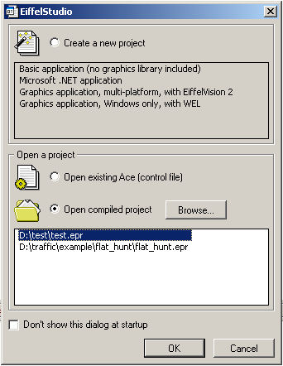
- The new classes should appear. If not, recompile your project.
- Open your root class.

Starting over... with the new version
- Create a new project, basic application, no graphics
- compile, wait a long time
- project settings, add libraries: gobo (from list), em & traffic (from path)
- root class: inherit em_application, traffic_3d_constants
- create new class for scene, inherit from em_component_scene
- in root_class: init video subsystem, set scene, launch
- in scene: make_component_scene
- should work now, displays nothing though
- add widgets to scene...

References
[1] Traffic library: http://se.inf.ethz.ch/traffic/
[2] Traffic guide: http://se.inf.ethz.ch/traffic/doc/traffic3.0_doc/general/installation/index.html
[3] Microsoft .NET Framework: http://msdn.microsoft.com/netframework/downloads/updates/default.aspx
[4] EiffelStudio: ftp://ftp.inf.ethz.ch/pub/mirror/eiffel/56/
[5] EiffelMedia: http://eiffelmedia.origo.ethz.ch/downloads/
[6] Ace-file template: template.ace

